Rešitve

Preverjanje znanja 5. razred

Whats's the time? Write the answers. (Koliko je ura? Napiši odgovore.)

What's the time?

**A**

|  |  |
| --- | --- |
| 12.45 | It's (**a) quarter to one.** pm – ni nujno uporabljati |
| 12.50 | It’s ten to one. |
| 13.00 | It’s one o’clock. |
| 13.15 | It's (**a) quarter past one.** |
| 13.20 | It’s twenty past one. |
| 13.30 | It’s half past one. |
| 14.45 | It’s (a) quarter to three. |

**B**

|  |  |
| --- | --- |
|  | It’s *eight o’clock.*  *It’s (a) quarter past three.*  *It’s half past nine.*  *It’s (a) quarter to seven.* |

**My day: Talk about your avarage day.** (Čim bolj podrobno opiši svoj običajen dan. Napiši vsaj 10 povedi.)

I wake up at half past six. I get up at a quarter to seven. I eat my breakfast at seven o’clock. I have a shower at (a) quarter past seven. I brush my teeth and get dressed. I go to school at eight a clock.

I start lessons at twenty past eight. At five to ten, we have a school lunch./I finish school at one a clock. (Then) I go to the school canteen and eat lunch. I go home at half past one. I have dance practice at half past three. I come back home at five o’clock. I eat dinner at (a) quarter past five. Then I have a shower. After that I do my homework and I study. At 8 o’clock, I (sometimes) watch TV. (Sometimes) I play board games and (sometimes) I read. At half past nine, I brush my teeth and go to bed.

**Describe LIAM’s day**. Opiši Liamov dan.

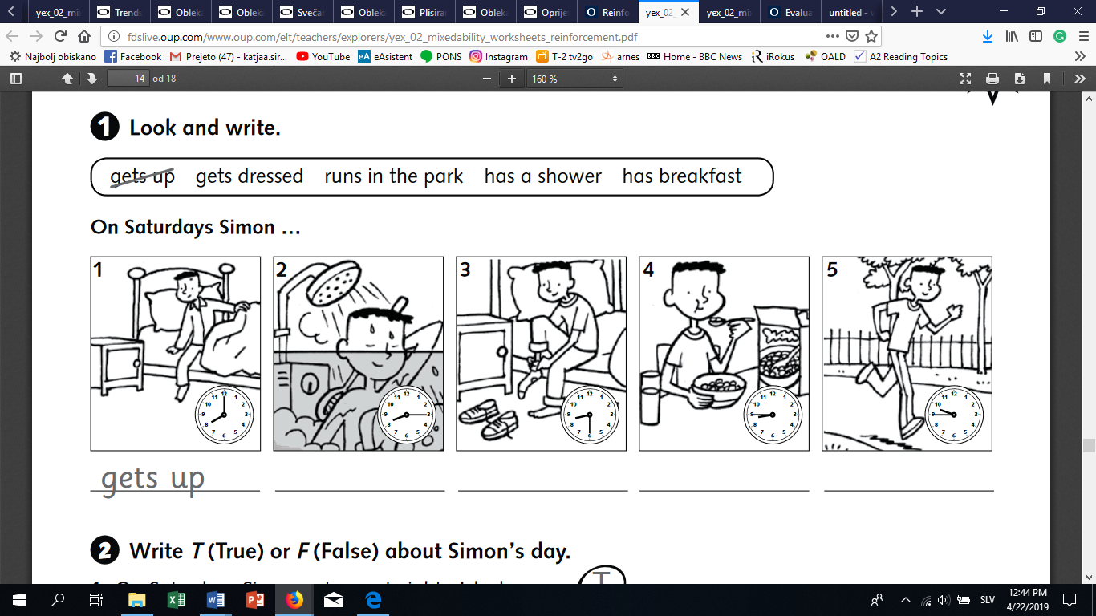

1 He gets up at eight o’clock.

2. He has a shower at (a) quarter past eight. /He takes a shower at (a) quarter past eight.

3. He gets dressed at half past eight.

4. He eats breakfast at a quarter to nine.

5. He goes to school at a quarter to ten.

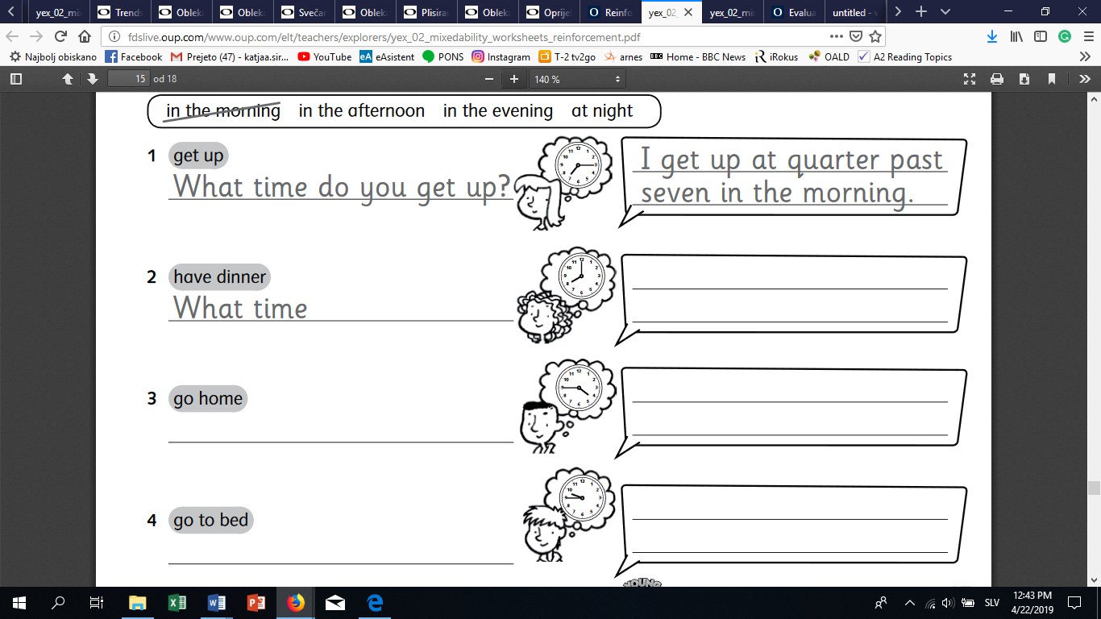**Write questions and answers.** Napiši vprašanja in odgovore. Pomagaj si s primerom.

What time do you go home?

What time do you have dinner?

I have dinner at 6 o'clock in the evening.

I go home at half past one in the afternoon.

I go to bed at half past nine in the evening.

What time do you go to bed?

**Write questions and answers**. Ponudi in vljudno sprejmi oz. zavrni ponudbo.

|  |  |
| --- | --- |
| A: Would you like a mango?  B: Yes, please. | A: Would you like an apple?  B: No, thank you. |
| A: Would you like some fish?  B: No, thank you. | A: Would you like some bread?  B: Yes, please. |

**Name the animals.** Poimenuj živali, pazi na množino! Stavke začni z “There are…”

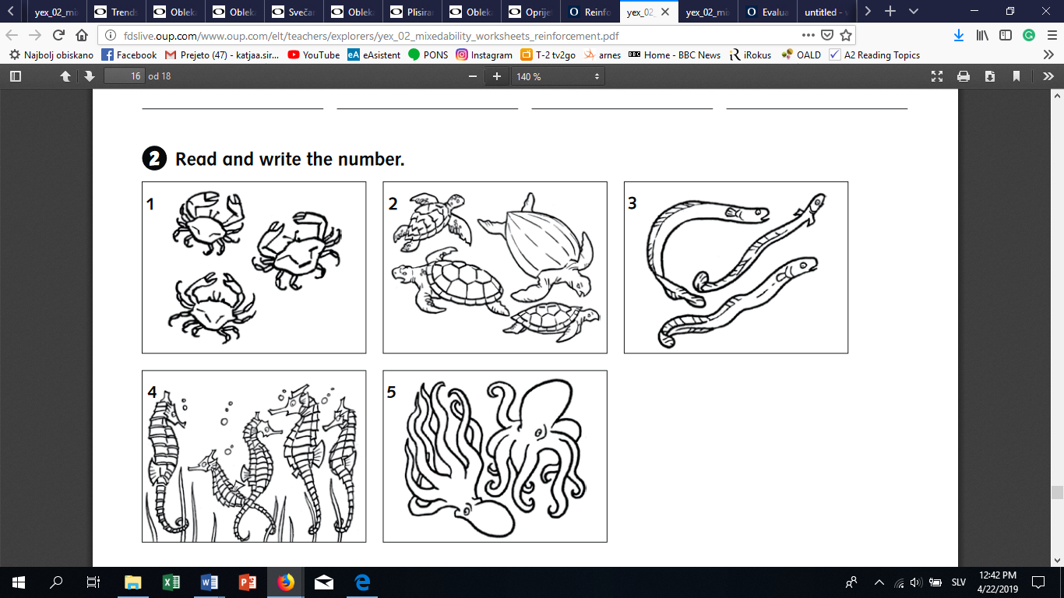

6

1 There are three crabs.

2 There are four turtles.

3 There are three eels.

4 There are five seahorses.

5 There are two octopuses.

6