V tem tednu nadaljujemo z obravnavo 6. enote – Under the sea. Naučili se boste, kako povedati, kaj se je zgodilo nekoč v preteklosti – včeraj, pred tremi dnevi, lansko poletje.
V slovenščini to imenujemo »pretekli čas«, Angleži mu pravijo »Past Simple Tense«

TOREK
- 10 minut nameni ponavljanju besedišča, ki si se ga naučil prejšnji teden.- Učbenik, str. 68, zvezek (delovni listi).
- Ustno naredi nalogi 3 in 4. Čim bolj natančno opiši sliko iz učbenika in sliko, ki jo vidiš.
Uporabi THERE IS/ THERE ARE
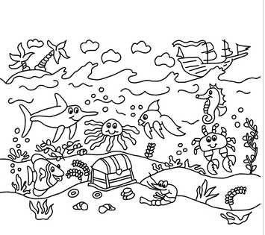

ČETRTEK:
Poslušaj, sledi besedilu v učbeniku str 69, nal. 1 in tiho beri.
Nato poslušaj še dvakrat in glasno ponavljaj. Po potrebi posnetek vmes ustavi.
učbeniku str 69, nal. 2 Poglej si sličice. Nato večkrat preberi pogovor med Ryanom in Vineeto. Si ugotovil, kaj se pogovarjata?
(Dekle poskuša ugotoviti, katere živali je Ryan videl v akvariju.)
Najprej pozorno preberi novo učno snov nato jo v zvezek prepiši.
Kaj pomeni THERE WAS in THERE WERE? Kakšna je razlika med tema dvema izrazoma?
Ponovno si oglej sličice v nalogi št. 2. Preberi pogovor med osebama A in B.

Zapiši v zvezek:
HOW WAS THE AQUARIUM?

THERE WAS/WERE

THERE WAS + stvar/oseba v ednini = tam je bil/a/o  There was an eel. | THERE WERE + stvari/osebe v množini = tam so bili/e  There were two crabs.

Naloga 2:

A: There was an octopus and there were two starfish. There was also a turtle.

B: Picture C.

A: Yes! Your turn.

Your turn. Write a new dialogue. Še ti napiši pogovor.

A:__________________________________________________________________
B:__________________________________________________________________
A:__________________________________________________________________

Sedaj pa : glasno vadi pogovor- lahko tudi sam. Igraj obe vlogi (fanta in dekleta) ali pa za pomoč prosi starše, brata, sestro. Lahko pokličeš tudi sošolca/ko in igrico igraš po telefonu, skypu. Lahko je zelo zabavno.
Reši še: Delovni zvezek str. 57:
1. Glej primer. Obkroži was ali were.
2. Napiši was ali were.
To stran v delovnem zvezku fotografiraj in jo oddaj kot nalogo.

PETEK
- Prilepi delovni list (če nimaš možnosti tiskanja ga prepiši).
- Ustno opiši sliko. Govori naglas in razločno. Uporabi THERE WAS/ THERE WERE

Preberi:

WAS in WERE
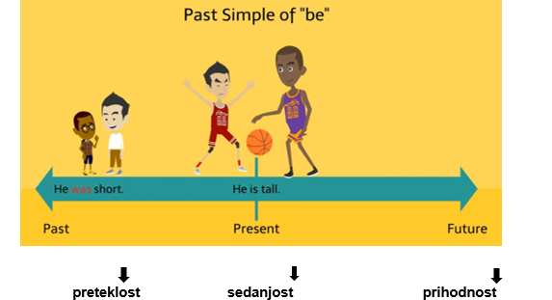
Present Tense (sedaj) | Past Tense  (nekoč v preteklosti)
She is 12 years old.  Stara je 12 let. | She was 11 last year.  Lani je bila stara 11 let.

SEDANJIK- glagol biti  I AM at the ZOO. - (Jaz) sem v živalskem vrtu.  YOU ARE at the ZOO.- Ti si v živalskem vrtu.  SHE IS at the ZOO. - ONA JE v živalskem vru.  HE IS at the ZOO. - ON JE v živalskem vru.  IT IS at the ZOO. -ONO (PREDMETI, ŽIVALI) JE v živalskem vru.  WE ARE at the ZOO.- MI SMO v živalskem vru.  YOU ARE at the ZOO. - VI STE v živalskem vru.  THEY ARE at the ZOO. - ONI SO v živalskem vru. | PRETEKLIK- Glagol biti  I WAS at the zoo, yesterday. Včeraj sem bil(a) v živalskem vrtu.  YOU WERE at the zoo, yesterday. Včeraj si bil v živalskem vrti  SHE WAS at the zoo, yesterday. Včeraj je bila v živalskem vrtu  HE WAS at the zoo, yesterday. Včeraj je bil v živalskem vrtu  IT WAS at the zoo, yesterday. Včeraj je bilo (predmet, žival) v živalskem vrtu  WE WERE at the zoo, yesterday. Včeraj smo bili v živalskem vrtu  YOU WERE at the zoo, yesterday. Včeraj ste bili v živalskem vrtu  THEY WERE at the zoo, yesterday. Včeraj so bili v živalskem vrtu
There is a polar bear.  Tam JE polarni medved.  There are two polar bears.  _____________________________________  There are a bear, a tiger and a lion  _____________________________________ | 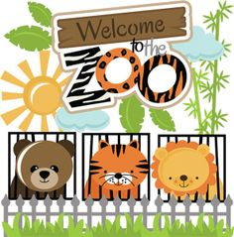  There was a polar bear.  Tam JE BIL polarni medved  There were two polar bears.  _____________________________________  There were a bear, a tiger and a lion.  _____________________________________
DELOVNI LIST

TODAY (danes): | YESTERDAY(včeraj):
We ____________ at school.  There _____________ a cat.  They _____________ at the cinema.  She _____________ hungry.  There _____________ a whale.  There _____________ two sharks.  Tom and Anna _____________ at the park. | We _____________are at school.  There _____________ a cat.  They _____________ at the cinema.  She _____________ hungry.  There _____________ a whale.  There _____________ two sharks.  Tom and Anna _____________ at the park.
DOPOLNI

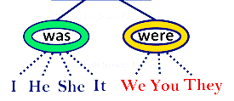
BE-GLAGOL BITI V PRETEKLOSTI

Rešitve
today
We are at school.  There is a cat.  They are at the cinema.  She is hungry.  There is a whale.  There are two sharks.  Tom and Anna are at the park. | We were at school.  There was a cat.  They were at the cinema.  She was hungry.  There was a whale.  There were two sharks.  Tom and Anna were at the park.

DZ:
