REŠITVE : 1. URA (11. TEDEN)

UČBENIK
Str. 101
1 C 2 E 3 A 4 B 5 D

Str. 102
1 A  A football match (the World Cup Final).  final – finale (zaključna tekma)  match – tekma  1 B  1 b 2 a 3 b | 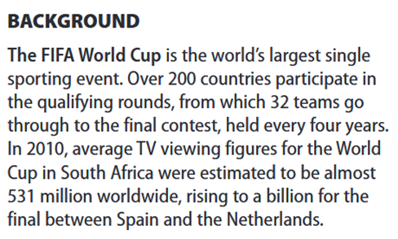

2 A
Kakšen je končni rezultat na koncu pogovora? Brazil 4 – France 3
2 B
Is Annie watching the match in Australia? (Yes.)
Why is Mr Kelly wearing green and yellow? (Because he’s supporting Brazil.)

1The Kellys.
2They’re watching the World Cup Final.
3 Green and yellow scarf.
4 Next to Mr Kelly.
5 Because Joe’s supporting Brazil and Sadie’s supporting France.

